Lecture 1 Worksheet

Operations and Data Types

1)

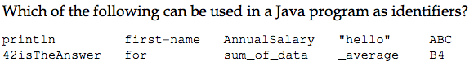

println, AnnualSalary, sum_of_data,_average, ABC, B4

2)



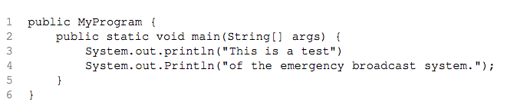

1)public class

2)Println should be lower case

3)missing ;

3)

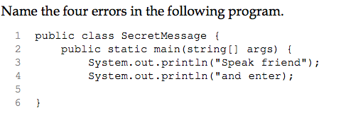

1)missing void

2)String should be capitalized

3)missing quotation on line 4

4)missing } for main method

4)

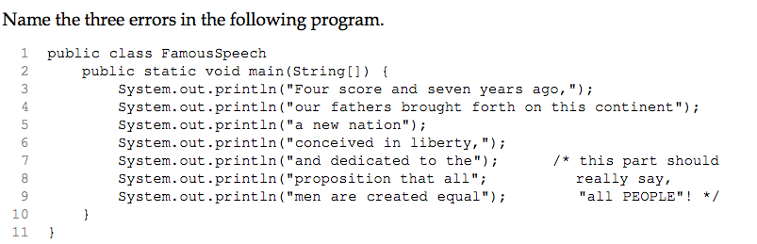

1)line 1 missing {

2) redo comment, put in ) in line 8

3)line2 missing args

5)



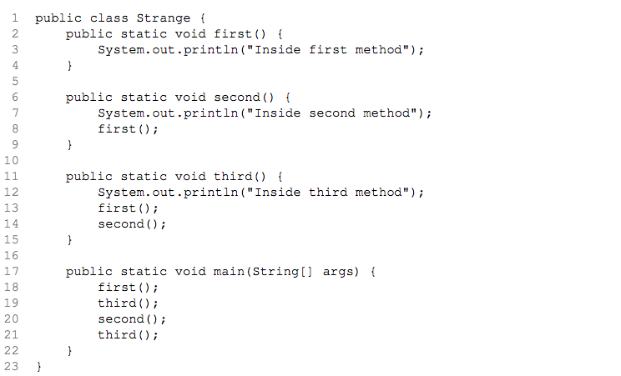

Inside first method.

Inside third method.

Inside first method.

Inside second method.

Inside first method.

Inside second method.

Inside first method.

Inside third method.

Inside first method.

Inside second method.

Inside first method.

6)



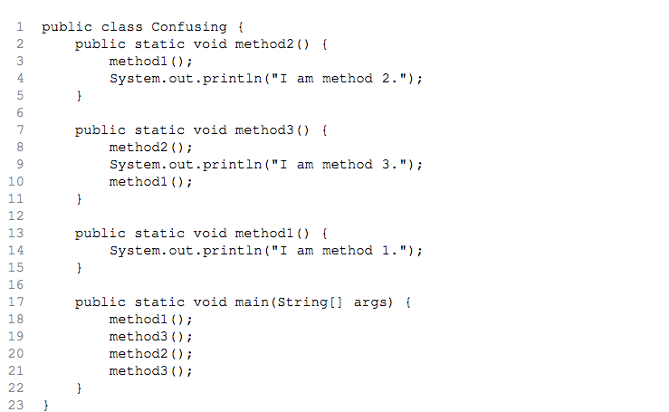

I am method 1.

I am method 1.

I am method 2.

I am method 3.

I am method 1.

I am method 1.

I am method 2.

I am method 1.

I am method 2.

I am method 3.

I am method 1.

7)



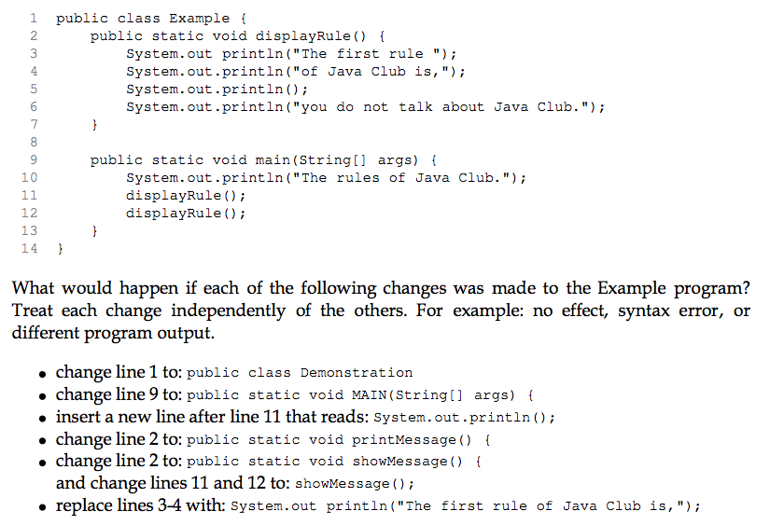

1)need to change file name

2)error, need a main method

3)different output

4)error since displayRule no longer exists when called

5)no effect

6)different output

8)

